inventory

Documentation

Table of Contents

Inventory Overview 2

Upload Products 2

Customer File 2

Odoo format 3

Import record 3

Upload Product variants Default Code 4

Upload Product variants Price 4

Inventory Products 5

Products Categories 6

Add new Category 6

Products Attributes 7

Odoo Studio 8

New Product 8

Attribute Tap 9

inventory Tap 9

Warehouse Management 10

Warehouses 10

Technical Information Tap 10

Operations Types 11

Operation Type 11

Locations 12

Sub location 12

Putaways Rules 13

Adjustments 14

Physical Inventory 14

Scrap Orders 14

Landed Costs 15

# Inventory Overview

1

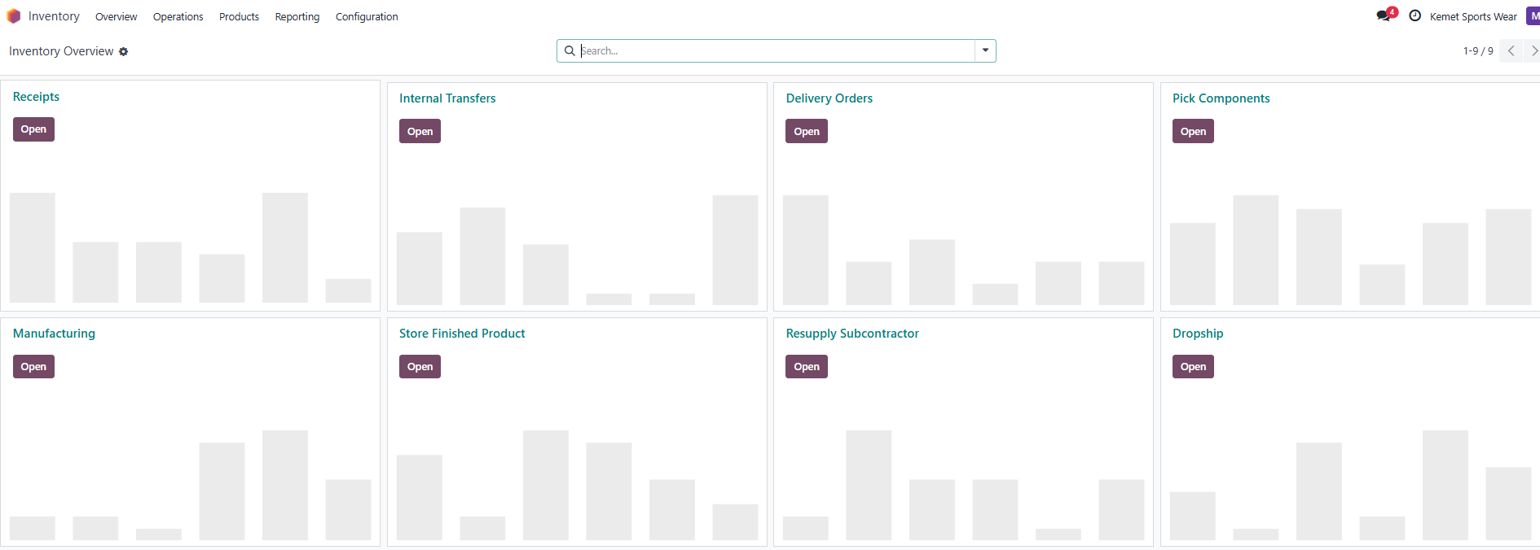

# Upload Products

## Customer File

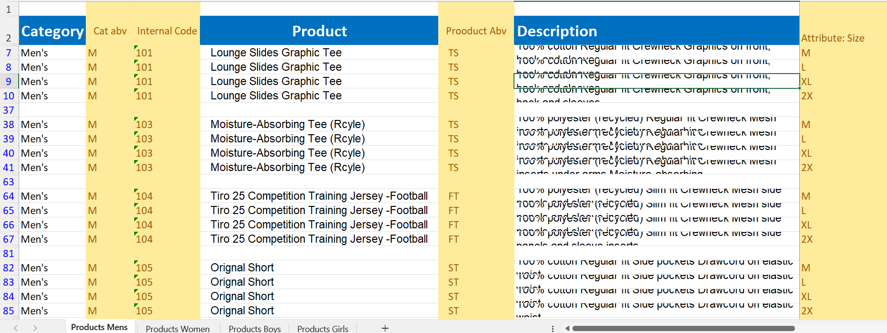

## Odoo format

2

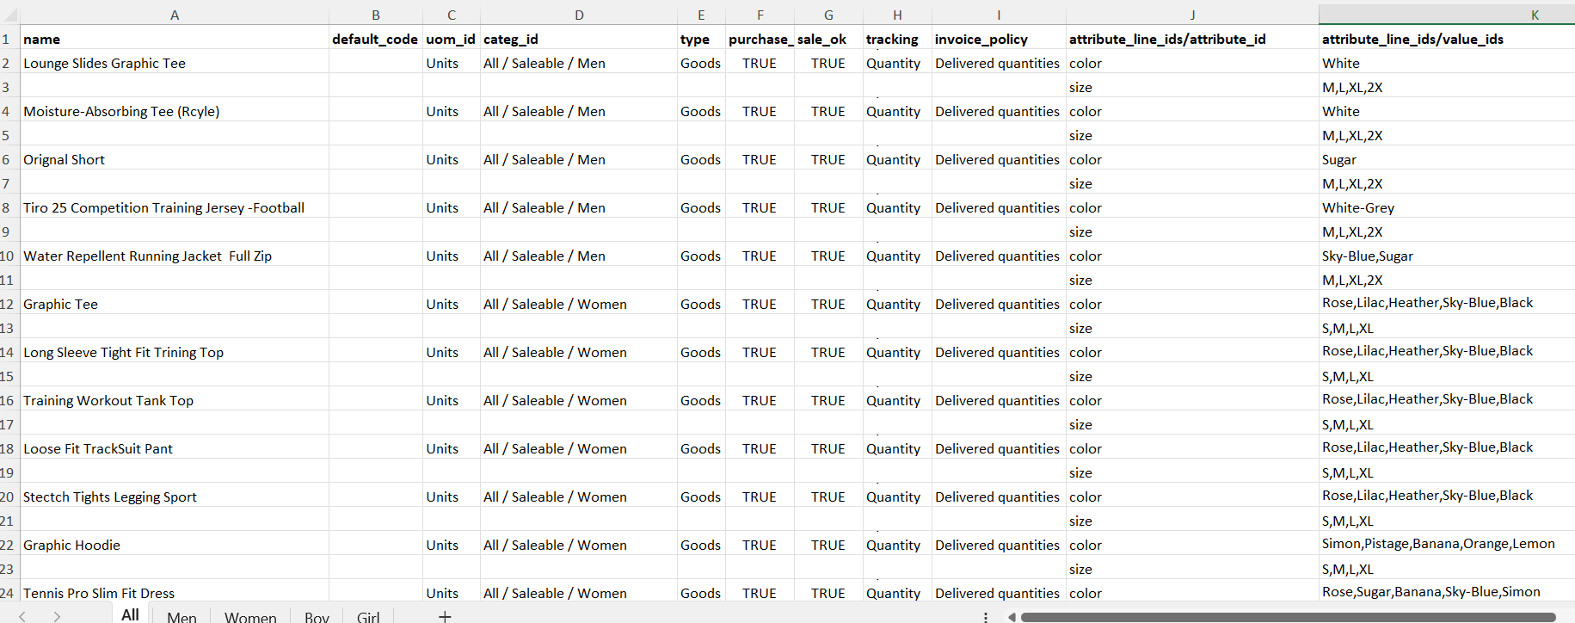

## Import record

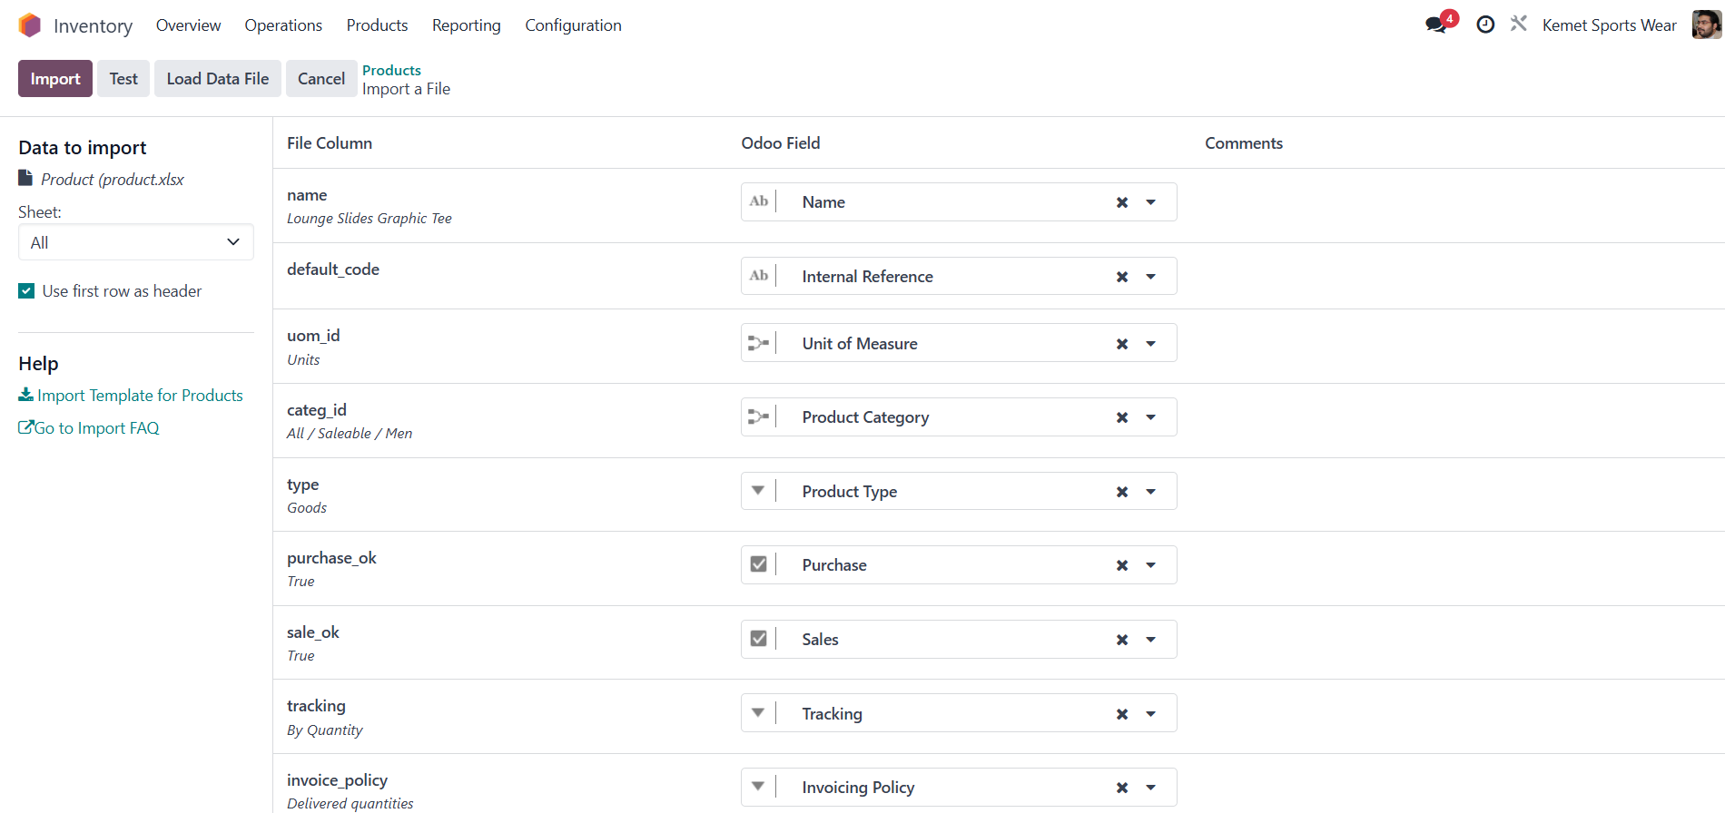

## Upload Product variants Default Code

3

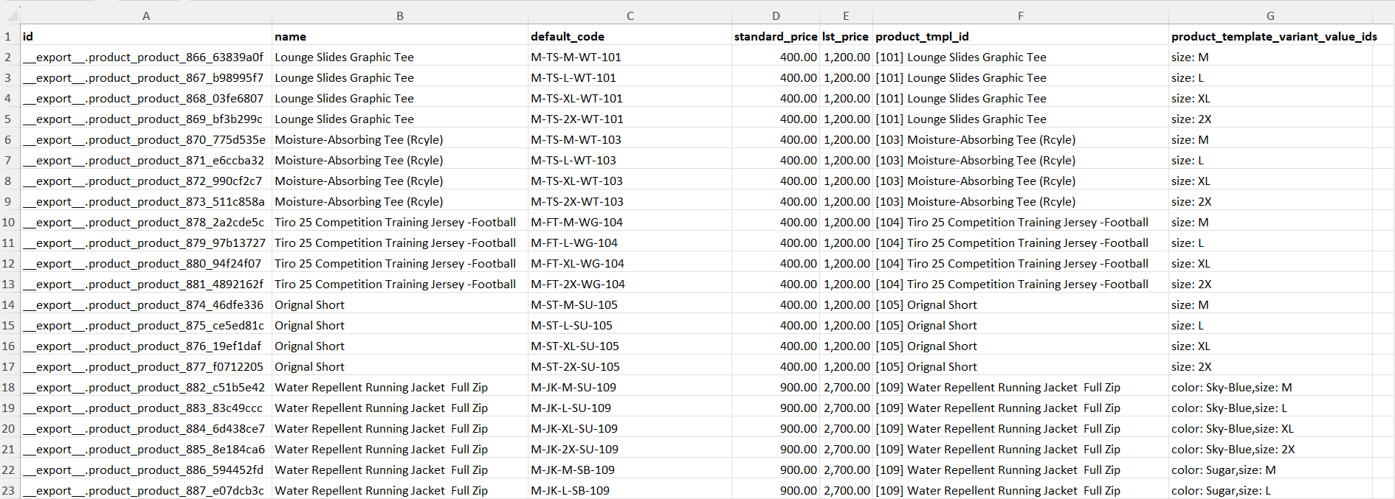

## Upload Product variants Price

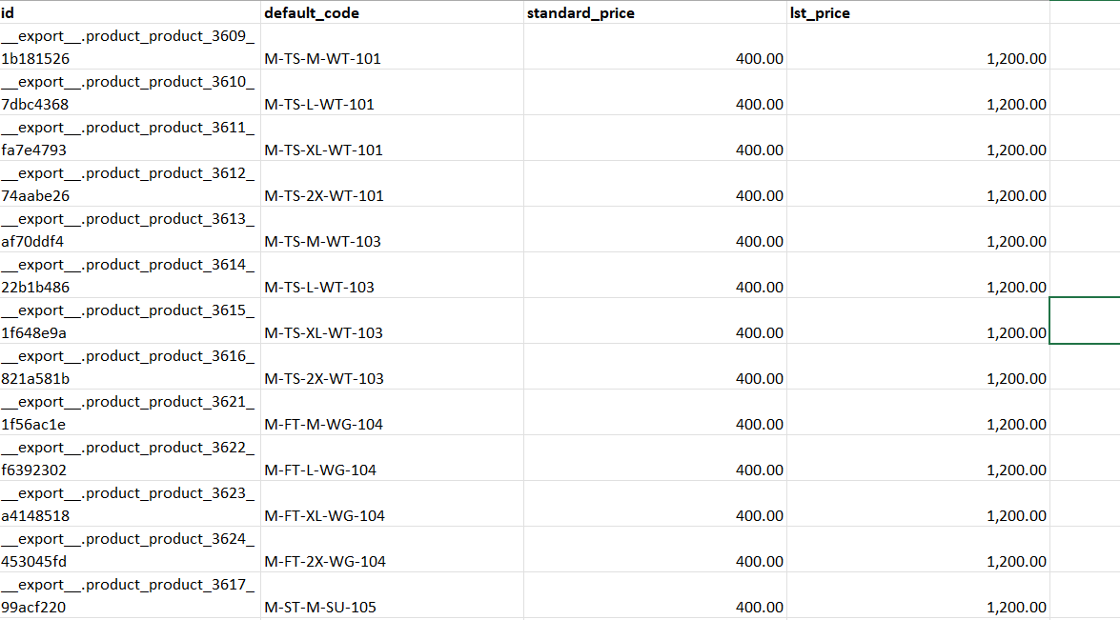

# Inventory Products

4

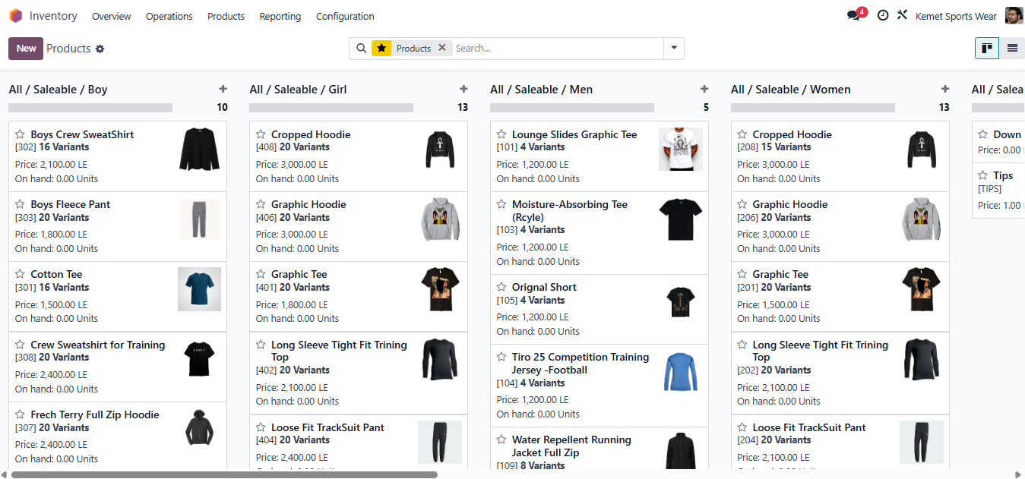

## Products Categories

5

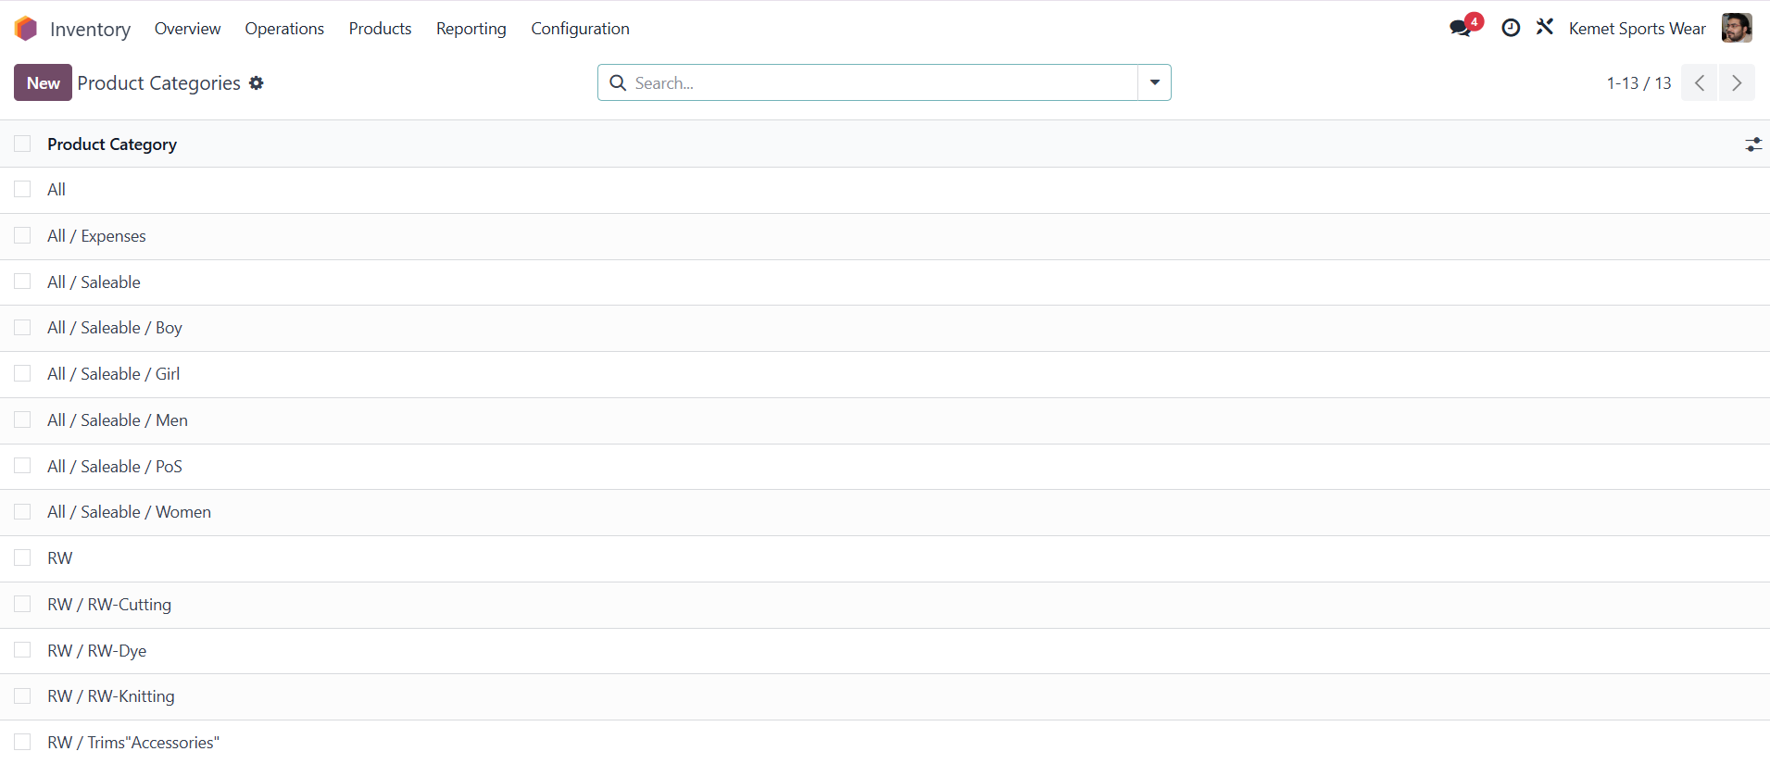

### Add new Category

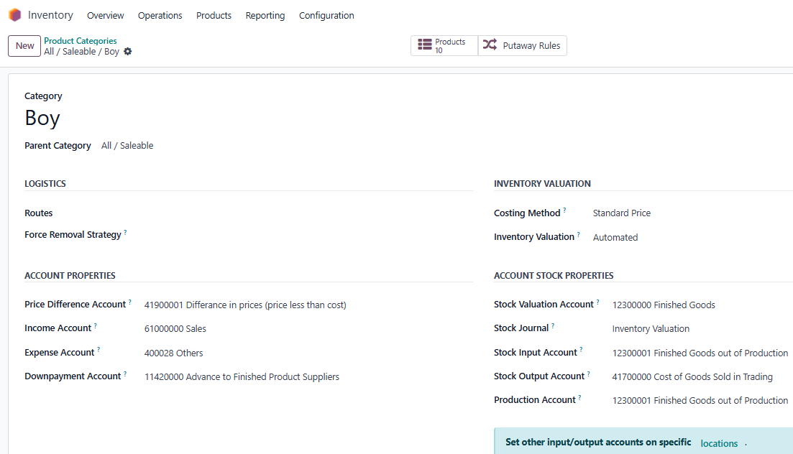

### Products Attributes

6

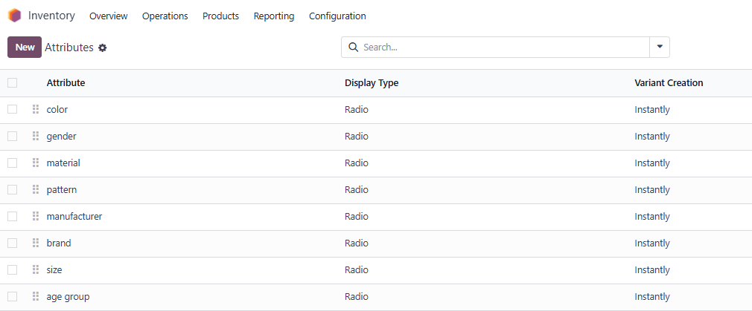

#### Add & Update Attributes

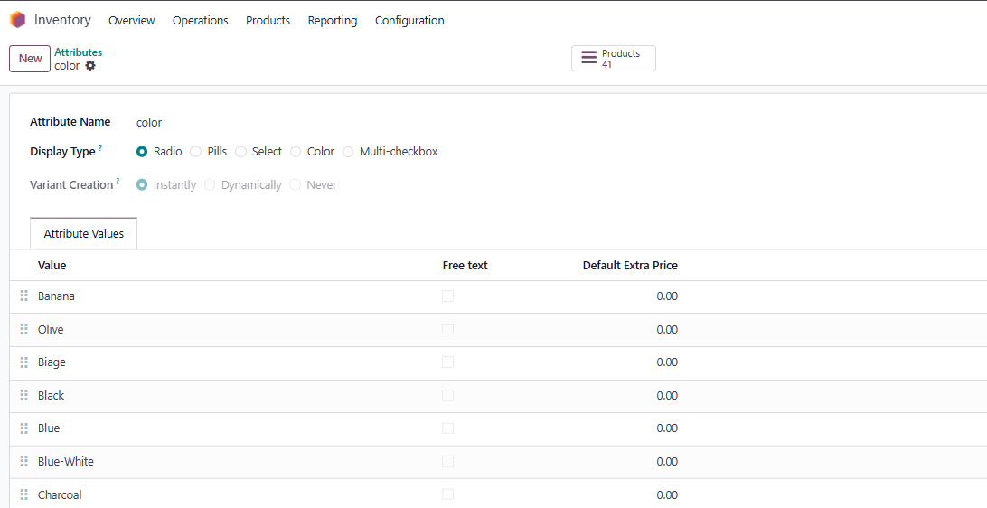

## Odoo Studio

To set Reference Field to Visible

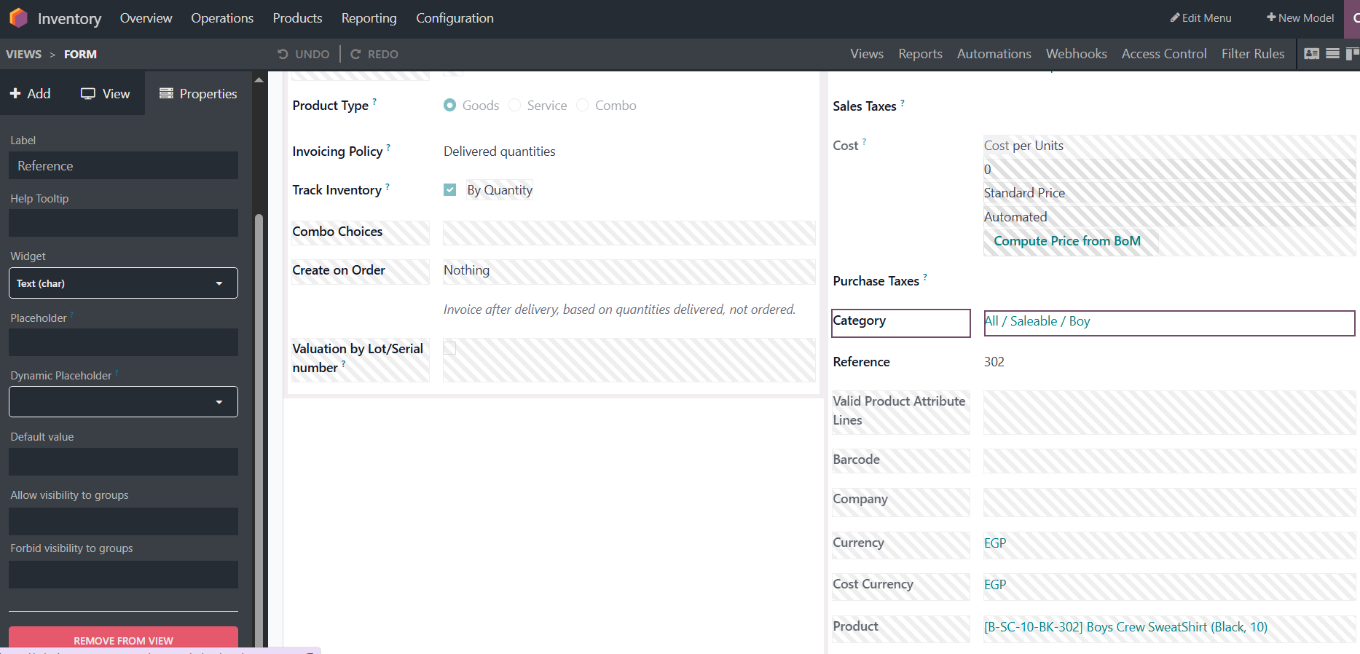

## New Product

7

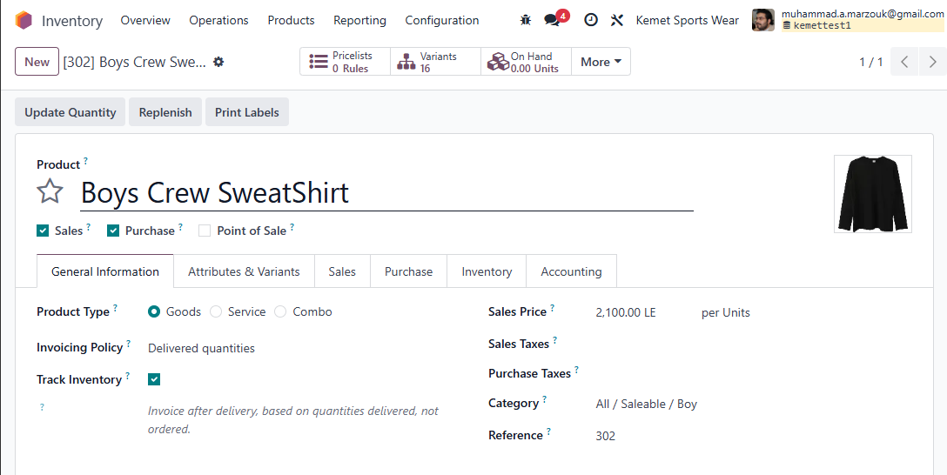

### Attribute Tap

8

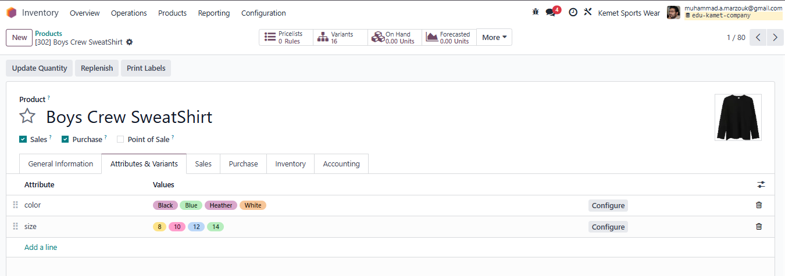

### inventory Tap

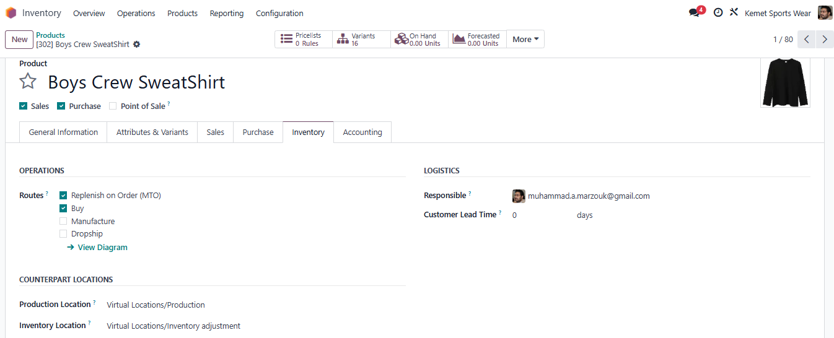

# Warehouse Management

9

## Warehouses

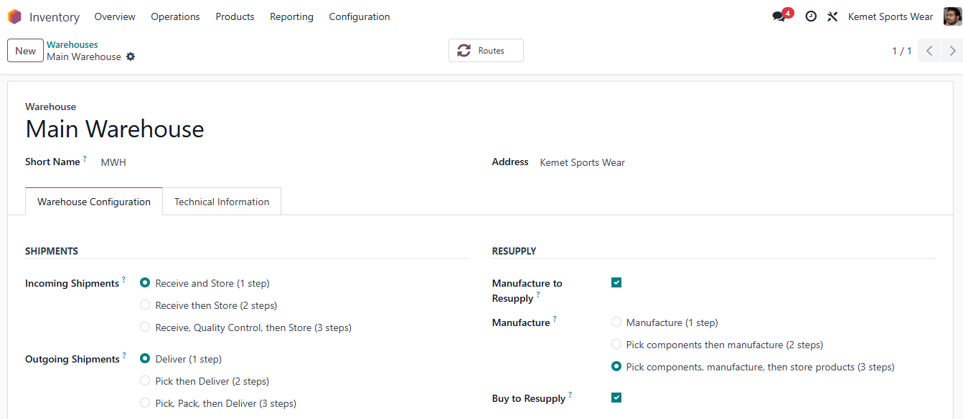

### Technical Information Tap

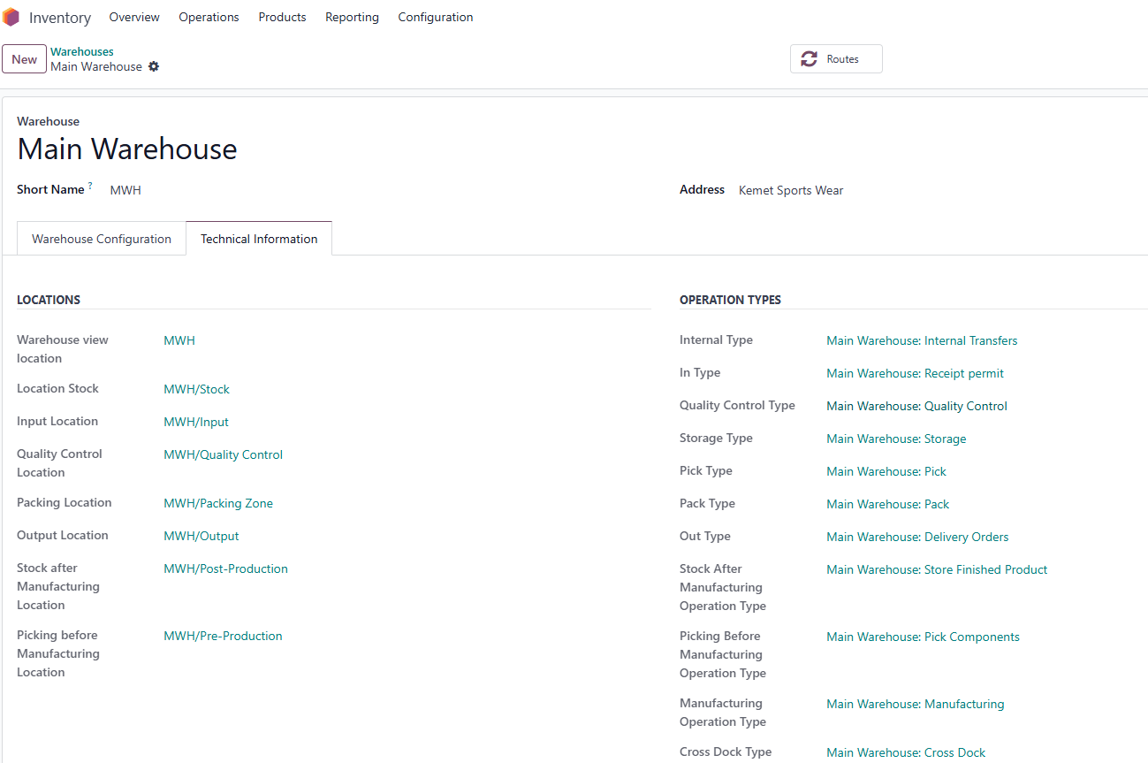

## Operations Types

10

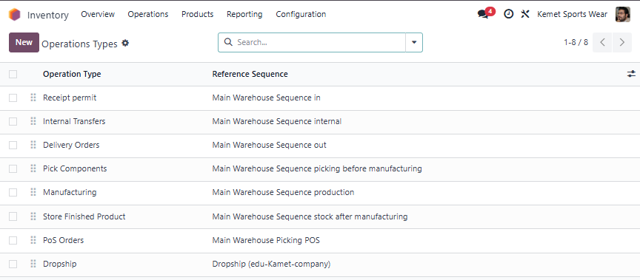

### Operation Type

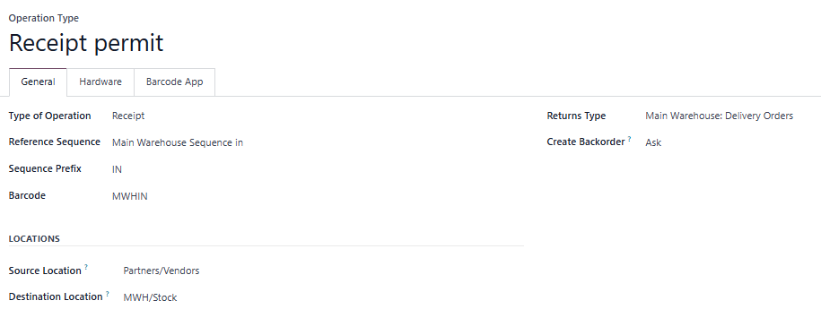

## Locations

11

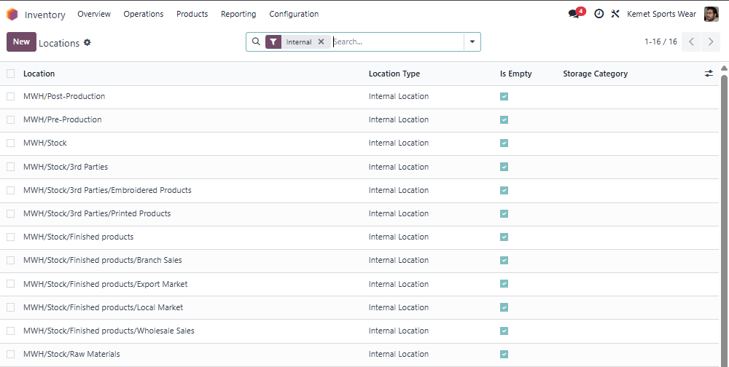

### Sub location

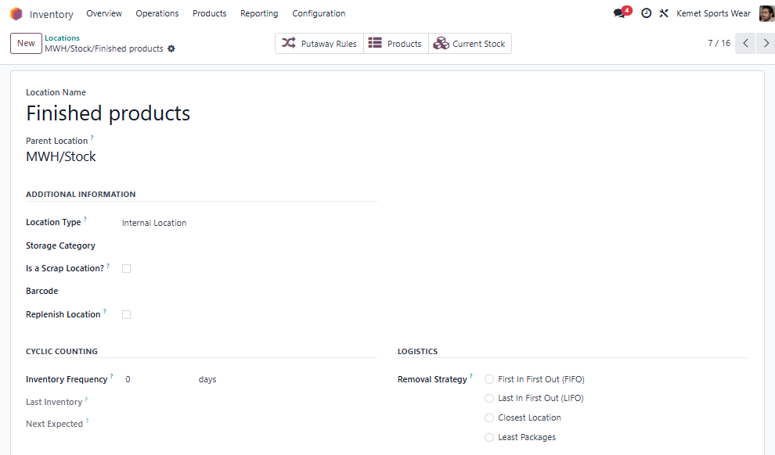

## Putaways Rules

12

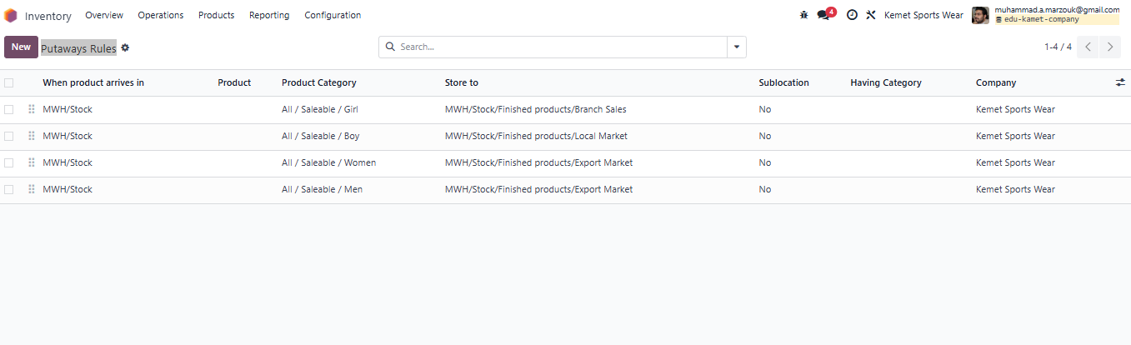

# Adjustments

## Physical Inventory

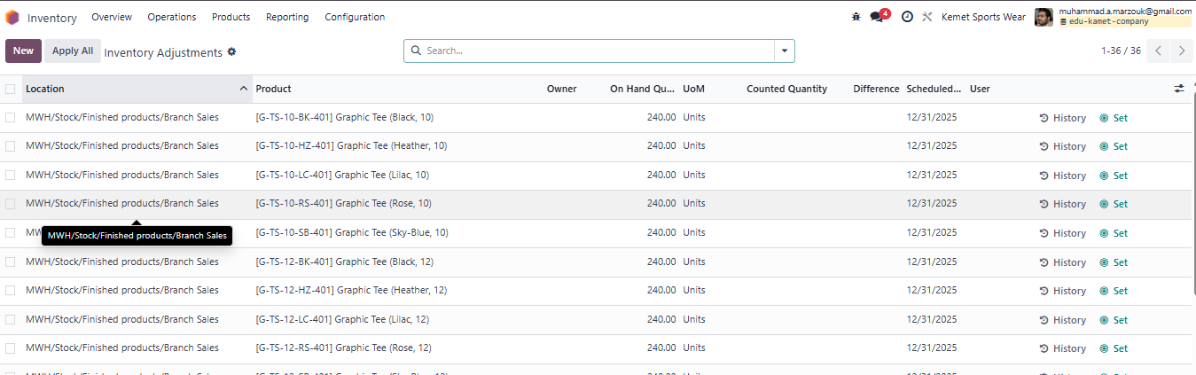

## Scrap Orders

13

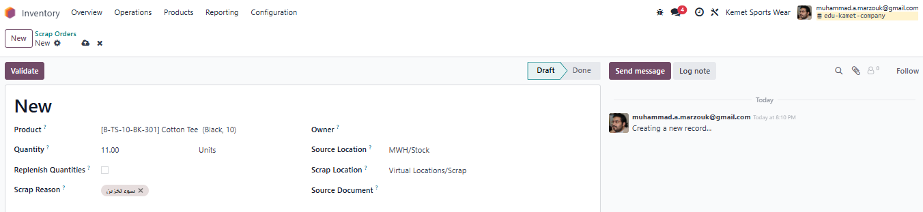

## Landed Costs

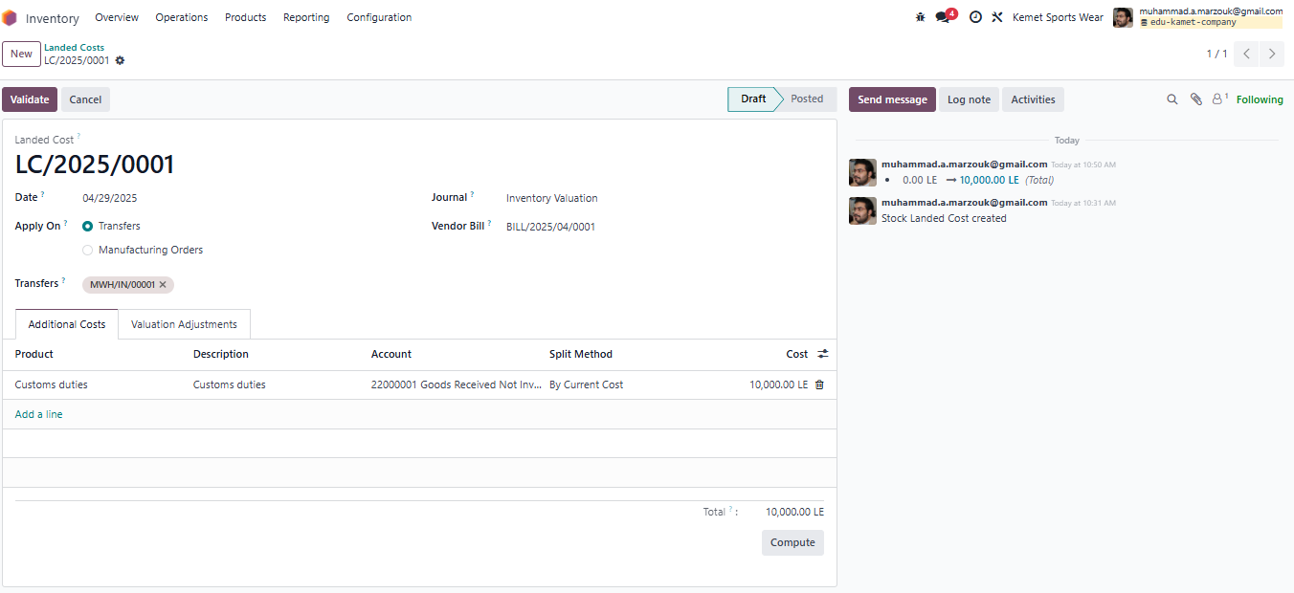

**Pro Sync integrated Solutions** **Kemet Sportswear Co.**

**Technical Manager**  **Project Manager**

Mr. Mohamed Marzouk MR. Atef Ibrahim